## Usability test

Usability testing is concerned with the intuitiveness of the system, testing on users who had no prior experience with the system (Nielsen, 1994). The number of users to conduct the test with was chosen to be five, since it is said that the best result come from testing no more than 5 users (Nielsen, 2000).

Before the actual test, series of scenarios were set for the users to follow. Then the users were asked to complete the proposed scenarios and give a feedback upon it.

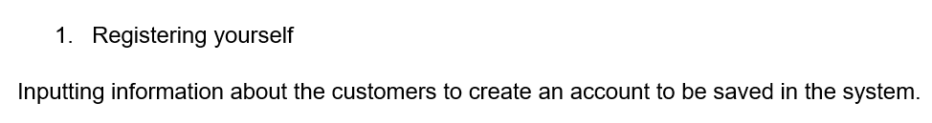

Figure: scenario of the usability test

The above figure is one of the examples of the scenario presented to the user. Users were testing system firstly as a customer and then as an operator. Both types of these users had their own scenarios. These scenarios can be found in Appendix.

The users were not provided with a user manual prior to the testing. The user manual can be found in Appendix.

Part of the result of one of the testers is shown below. The full usability test can be found in Appendix.

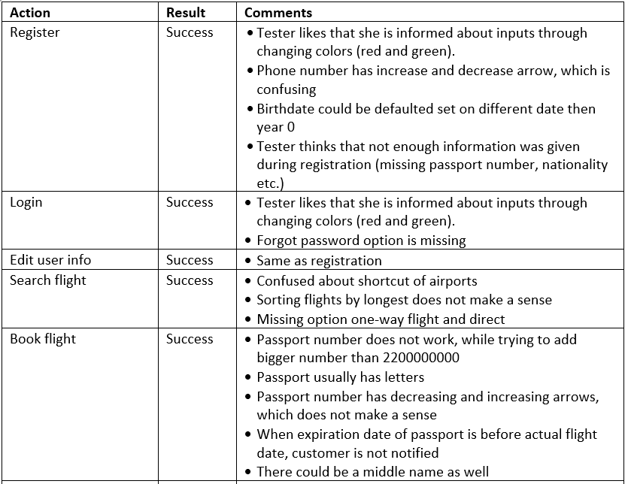

One of the biggest criticisms from all the testers was during the cancelation of the flight. When testers cancelled their flight, no confirmation about cancelling was displayed and flight was cancelled. Another big criticism was about searching flight. Most of the testers wanted to look up for flights with return flight, but this function is not available. Another big criticism came during paying for the ticket. Most of the testers were confused about the price and they did not know how the price was counted. The last big criticism came during choosing luggage, where no price is displayed. Tester would like to be more informed about prices for each luggage as about the overall price for the ticket.

These problems will be further discussed in the Results and Discussion, and Project Future sections.